Periodic Table

The Periodic Table arranges the elements according to their chemical properties.

Metals are found to the left hand side of the zig-zag on the table. Non-metals are found to the right.

Elements on either side of the zig-zag are called semi-metals or metalloids, showing characteristics of both metals and non-metals.

Hydrogen is a non-metal that behaves like a Group I element sometimes and a Group VII at other times. It is sometimes shown by itself in the table.

All metals with the same chemical properties are arranged in groups (vertical columns). They are numbered from I - VIII across the table.

The horizontal rows are called periods.

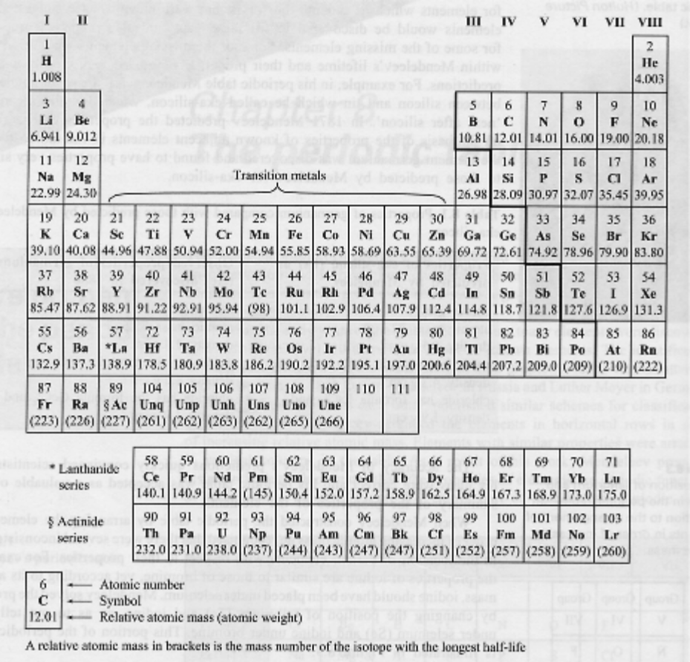

Special Names of Elements

Alkali Metals
• Group I
• React with H₂O to form alkaline or basic solutions.

Alkaline Earth Metals
• Group II.

Halogens
• Group VII.

Inert (Noble) Gases
• Group VIII.
• Unreactive.
• Exist as single atoms.

Transition Metals
• Found in the middle of the table.
• Elements near each other have similar properties.
• Tend to form coloured compounds with non-metals.

